How Seatbelts Work  by Tom Harris  ››Tell a friend about this article! |  | › Introduction to How Seatbelts Work  › Crashing Concepts  › Taking a Hit  › Extend and Retract  › The Pretensioner  › Load Limiters  › Lots More Information!  › Search Google  › Shop or Compare Prices  › What do you think?
According to the National Highway Traffic and Safety Administration, seatbelts saved nearly 12,000 lives in the United States in the year 2000. The NHTSA estimates that more than 9,000 U.S. car accident fatalities in 2000 would have been avoided if the victims had been wearing belts. While seatbelts do occasionally contribute to serious injury or death, nearly all safety experts agree that buckling up dramatically increases your chances of surviving an accident. According to the NHTSA, seatbelts reduce the risk of death for a front seat car occupant by about 45 percent.
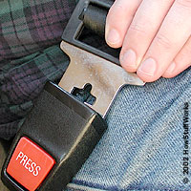
When you think about it, this is absolutely amazing: How can a piece of fabric end up being the difference between life and death? What does it actually do? In this edition of HowStuffWorks, we'll examine the technology of seatbelts to see why they are one of the most important technologies in any car.

Crashing Concepts
The basic idea of a seatbelt is very simple: It keeps you from flying through the windshield or hurdling toward the dashboard when your car comes to an abrupt stop. But why would this happen in the first place? In short, because of inertia.
Inertia is an object's tendency to keep moving until something else works against this motion. To put it another way, inertia is every object's resistance to changing its speed and direction of travel. Things naturally want to keep going.
If a car is speeding along at 50 miles per hour, inertia wants to keep it going 50 mph in one direction. Air resistance and friction with the road are constantly slowing it down, but the engine's power compensates for this energy loss.
Anything that is in the car, including the driver and passengers, has its own inertia, which is separate from the car's inertia. The car accelerates riders to its speed. Imagine that you're coasting at a steady 50 miles per hour. Your speed and the car's speed are pretty much equal, so you feel like you and the car are moving as a single unit.
But if the car were to crash into a telephone pole, it would be obvious that your inertia and the car's were absolutely independent. The force of the pole would bring the car to an abrupt stop, but your speed would remain the same. Without a seatbelt, you would either slam into the steering wheel at 50 miles per hour or go flying through the windshield at 50 miles per hour. Just as the pole slowed the car down, the dashboard, windshield or the road would slow you down by exerting a tremendous amount of force.
It is a given that no matter what happens in a crash, something would have to exert force on you to slow you down. But depending on where and how the force is applied, you might be killed instantly or you might walk away from the damage unscathed.
If you hit the windshield with your head, the stopping power is concentrated on one of the most vulnerable parts of your body. It also stops you very quickly, since the glass is a hard surface. This can easily kill or severely injure a person.
A seatbelt applies the stopping force to more durable parts of the body over a longer period of time. In the next section, we'll see how this reduces the chances of major injury.

Taking a Hit
In the last section, we saw that any time a car comes to a sudden stop, a passenger comes to a sudden stop as well. A seatbelt's job is to spread the stopping force across sturdier parts of your body in order to minimize damage.
A typical seatbelt consists of a lap belt, which rests over your pelvis, and a shoulder belt, which extends across your chest. The two belt sections are tightly secured to the frame of the car in order to hold passengers in their seats.
When the belt is worn correctly, it will apply most of the stopping force to the rib cage and the pelvis, which are relatively sturdy parts of the body. Since the belts extend across a wide section of your body, the force isn't concentrated in a small area, so it can't do as much damage. Additionally, the seatbelt webbing is made of more flexible material than the dashboard or windshield. It stretches a little bit, which means the stop isn't quite so abrupt. The seatbelt shouldn't give more than a little, however, or you might bang into the steering wheel or side window. Safe seatbelts will only let you shift forward slightly.
A car's crumple zones do the real work of softening the blow. Crumple zones are areas in the front and rear of a car that collapse relatively easily. Instead of the entire car coming to an abrupt stop when it hits an obstacle, it absorbs some of the impact force by flattening, like an empty soda can. The car's cabin is much sturdier, so it does not crumple around the passengers. It continues moving briefly, crushing the front of the car against the obstacle. Of course, crumple zones will only protect you if you move with the cab of the car -- that is, if you are secured to the seat by your seatbelt.
The simplest sort of seatbelt, found in some roller coasters, consists of a length of webbing bolted to the body of the vehicle. These belts hold you tightly against the seat at all times, which is very safe but not particularly comfortable.
Car seatbelts have the ability to extend and retract -- you can lean forward easily while the belt stays fairly taut. But in a collision, the belt will suddenly tighten up and hold you in place. In the next section, we'll look at the machinery that makes all this possible.

Extend and Retract
In a typical seatbelt system, the belt webbing is connected to a retractor mechanism. The central element in the retractor is a spool, which is attached to one end of the webbing. Inside the retractor, a spring applies a rotation force, or torque, to the spool. This works to rotate the spool so it winds up any loose webbing.
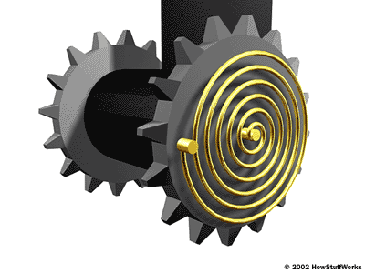
A spiraled spring rotates the spool to keep the seatbelt webbing taut.
When you pull the webbing out, the spool rotates counter-clockwise, which turns the attached spring in the same direction. Effectively, the rotating spool works to untwist the spring. The spring wants to return to its original shape, so it resists this twisting motion. If you release the webbing, the spring will tighten up, rotating the spool clockwise until there is no more slack in the belt.
The retractor has a locking mechanism that stops the spool from rotating when the car is involved in a collision. There are two sorts of locking systems in common use today:
- systems triggered by the car's movement
- systems triggered by the belt's movement
The first sort of system locks the spool when the car rapidly decelerates (when it hits something, for example). The diagram below shows the simplest version of this design.
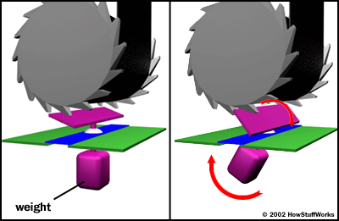
The central operating element in this mechanism is a weighted pendulum. When the car comes to a sudden stop, the inertia causes the pendulum to swing forward. The pawl on the other end of the pendulum catches hold of a toothed ratchet gear attached to the spool. With the pawl gripping one of its teeth, the gear can't rotate counter-clockwise, and neither can the connected spool. When the webbing loosens again after the crash, the gear rotates clockwise and the pawl disengages.
The second kind of system locks the spool when something jerks the belt webbing. The activating force in most designs is the speed of the spool rotation. The diagram shows a common configuration.
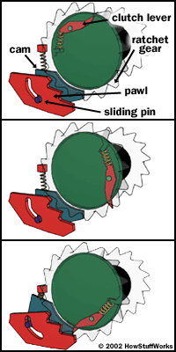
The central operating element in this design is a centrifugal clutch -- a weighted pivoting lever mounted to the rotating spool. When the spool spins slowly, the lever doesn't pivot at all. A spring keeps it in position. But when something yanks the webbing, spinning the spool more quickly, centrifugal force drives the weighted end of the lever outward.
The extended lever pushes a cam piece mounted to the retractor housing. The cam is connected to a pivoting pawl by a sliding pin. As the cam shifts to the left, the pin moves along a groove in the pawl. This pulls the pawl into the spinning ratchet gear attached to the spool. The pawl locks into the gear's teeth, preventing counter-clockwise rotation.
In some newer seatbelt systems, a pretensioner also works to tighten the belt webbing. In the next section, we'll see how these devices work.

The Pretensioner
The idea of a pretensioner is to tighten up any slack in the belt webbing in the event of a crash. Whereas the conventional locking mechanism in a retractor keeps the belt from extending any farther, the pretensioner actually pulls in on the belt. This force helps move the passenger into the optimum crash position in his or her seat. Pretensioners normally work together with conventional locking mechanisms, not in place of them.
There are a number of different pretensioner systems on the market. Some pretensioners pull the entire retractor mechanism backward and some rotate the spool itself. Generally, pretensioners are wired to the same central control processor that activates the car's air bags. The processor monitors mechanical or electronic motion sensors that respond to the sudden deceleration of an impact. When an impact is detected, the processor activates the pretensioner and then the air bag.
Some pretensioners are built around electric motors or solenoids, but the most popular designs today use pyrotechnics to pull in the belt webbing. The diagram below shows a representative model.
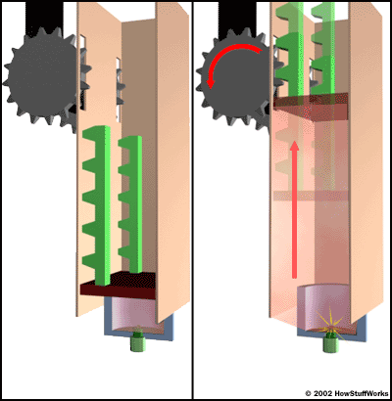
When the gas is ignited, the pressure pushes the piston up to rotate the retractor.
The central element in this pretensioner is a chamber of combustible gas. Inside the chamber, there is a smaller chamber with explosive igniter material. This smaller chamber is outfitted with two electrodes, which are wired to the central processor.
When the processor detects a collision, it immediately applies an electrical current across the electrodes. The spark from the electrodes ignites the igniter material, which combusts to ignite the gas in the chamber. The burning gas generates a great deal of outward pressure. The pressure pushes on a piston resting in the chamber, driving it upward at high speed.
A rack gear is fastened to one side of the piston. When the piston shoots up, the rack gear engages a gear connected to the retractor spool mechanism. The speeding rack rotates the spool forcefully, winding up any slack belt webbing.

Load Limiters
In severe crashes, when a car collides with an obstacle at extremely high speed, a seatbelt can inflict serious damage. As a passenger's inertial speed increases, it takes a greater force to bring the passenger to a stop. In other words, the faster you're going on impact, the harder the seatbelt will push on you.
Some seatbelt systems use load limiters to minimize belt-inflicted injury. The basic idea of a load limiter is to release a little more excess belt webbing when a great deal of force is applied to the belt. The simplest load limiter is a fold sewn into the belt webbing. The stitches holding the fold in place are designed to break when a certain amount of force is applied to the belt. When the stitches come apart, the webbing unfolds, allowing the belt to extend a little bit more.
More advanced load limiters rely on a torsion bar in the retractor mechanism. A torsion bar is just a length of metal material that will twist when enough force is applied to it. In a load limiter, the torsion bar is secured to the locking mechanism on one end and the rotating spool on the other. In a less severe accident, the torsion bar will hold its shape, and the spool will lock along with the locking mechanism. But when a great deal of force is applied to the webbing (and therefore the spool), the torsion bar will twist slightly. This allows the webbing to extend a little bit farther.
Over the years, seatbelts have proven to be far and away the most important safety device in cars and trucks. They are by no means infallible, however, and car safety engineers see a lot of room for improvement in today's design. In the future, cars will be outfitted with better belts, better air bags and, most likely, completely new safety technology. Of course, the government will still have to address the biggest problem with safety devices -- getting people to use them.
For more information on seatbelts and other safety systems, check out the links on the next page.

